## Assessment of Invasive Alien Species Distribution in the Chitwan-Annapurna-Landscape (CHAL) Region, Nepal

Principal Investigator:

Pramod Kumar Jha

Professor Emeritus

Central Department of Botany

Tribhuvan University

Kathmandu

Nepal

Co-Principal Investigator:

Madhav Marathe

Biocomplexity Institute

Virginia Tech

Blacksburg, VA

U.S.A.

Duration

May 1, 2018 to November 16, 2019

# Assessment of Invasive Alien Species Distribution in the Chitwan-Annapurna-Landscape (CHAL) Region, Nepal

## BACKGROUND

In 1992, the International Convention on Biological Diversity (CBD) pointed to the biological invasion of alien species as the second worst threat after habitat destruction and began to set global priorities and guidelines to collect information and coordinate international actions on Invasive Alien Species (IAS) management. One of the several new changes caused by climate change is the emergence of invasive species (IPCC, 2007). Warming of temperature is the major cause of climate change which supports to create a new habitat for the invasive species and agents of change, threatens native biological diversity (IUCN, 2000), transforms the structure and species composition of ecosystems (Ricchardi et al. 2004), displaces elements of native biota (Rejmanek, 1999), modifies regimes (Brooks et al. 2004) and changes ecosystem structure and functioning (Dukes and Mooney, 2004). In the meantime, the IAS have a broad range of tolerance (Walther et al., 2009); therefore, such species can grow faster and spread at an alarming rate. We propose to study the effect of global warming on the spread of ,invasive species of plants in Nepal as it provides an ideal platform to monitor temperature rise as well as invasion by some dominant weeds.

Nepal, a country located in the Central Himalaya, has tropical to alpine ecosystems. The country lies at 26º 22’ to 30º 27’ N and longitude of 80º 04’ to 88º 12’ E between India and China, stretched about 885 km from east to west and a width of 150 to 240 km from south to north. The total area of the country is 147,181 sq km, covering 0.09% of the total terrestrial surface and 0.03% of the total earth surface. Wide altitudinal variation within 180 km south-north land in Nepal is what makes the physiography unique. Altitude varies from 60 m in the south to 8,848 m high in Mt. Everest in the north, within an aerial distance of 180 km. Nepal has flat lowland in the south, hills and valleys in the middle and lofty Himalaya in the north. Traditional classification of physiography of Nepal has four divisions: Terai and Madhesh: the Indo-Gangetic alluvial plain; the Churia or Siwalik: outer Himalayan range; Mahabhrat lek: lesser Himalayan range; and Hills and Mountain: Palearctic ecozone. Dobremez (1976), while studying phytogeography, broadly categorized the country under six life zones coinciding with an altitudinal interval of 1000 m: (i) Tropical (below 1000 m), (ii) Subtropical (1000-2000 m), (iii) Temperate (2000-3000 m),(iv) Sub-alpine (3000-4000 m), (v) Alpine (4000-5000 m),and (vi) Nival (altitude>5000 m).

In Nepal, the recorded number of IAS species is 166 (Tiwari et al. 2005). IUCN (2013) strongly recommended, in a milieu of changing climate and acceleration of introduction and aggressiveness of IAS, more research to be carried out. Roadsides, grazing lands, edges of wetlands, disturbed forests, and abandoned farmlands have been invaded. Based on this information, it is highly essential for the habitat mapping of IAS to utilize Geo-Information techniques-based multi-criteria analysis in the Chitwan Annapurna Landscape (CHAL) and correlate it with increasing temperatures.

## GOAL AND OBJECTIVES

1. To map the habitat distribution of the major IAS over the time between 1990 and 2017.
2. To identify the high potential spatial location for most common IAS through Geo-Information-based multi-criteria analysis.
3. To draw a trend of distribution of IAS over the time and develop the linkage of IAS distribution and climate change as a proxy indicator.

## GEOGRAPHICAL EXTENSION OF CHAL

CHAL is located in central Nepal, covering an area of 32,057 sq km, with elevations ranging from 200m to 8,091m above sea level. The geographical extension of the area with intensive coverage of invasive species is known to be below 2,500 meter in the south face of the Himalayas. In the CHAL that covers 61.21% (19,622.3 sq km) area, the southern lowland and middle part of the region is extensively confined for the domination of invasive species; however, the river channels are further bending towards the north having lower elevation. Thus, the possibilities of invasive species are gradually increasing toward the northern part. The geographical extension of that elevation range is between 82° 54' 35'' to 85° 29' 58'' east longitude and 27° 20' 48'' to 28° 34' 00'' north latitude (Fig.1 and 2).

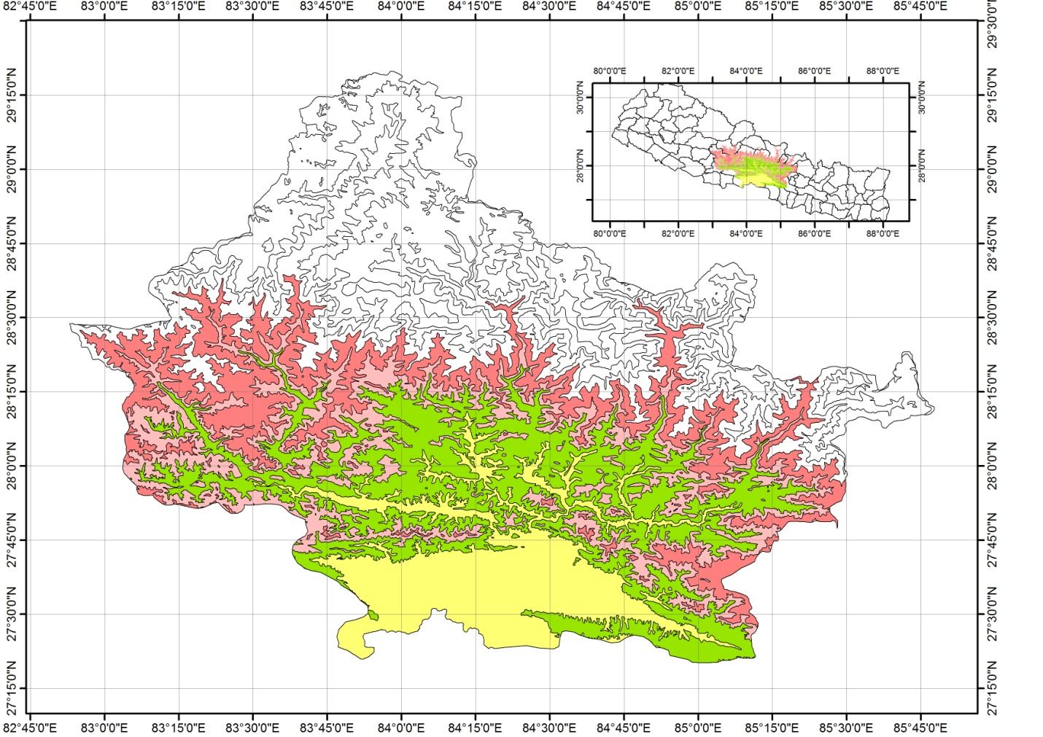

Figure 1: The shaded area presents CHAL boundary below 2,500m from the mean sea level (msl), Source: Topographical Map, Department of Survey, Government of Nepal).

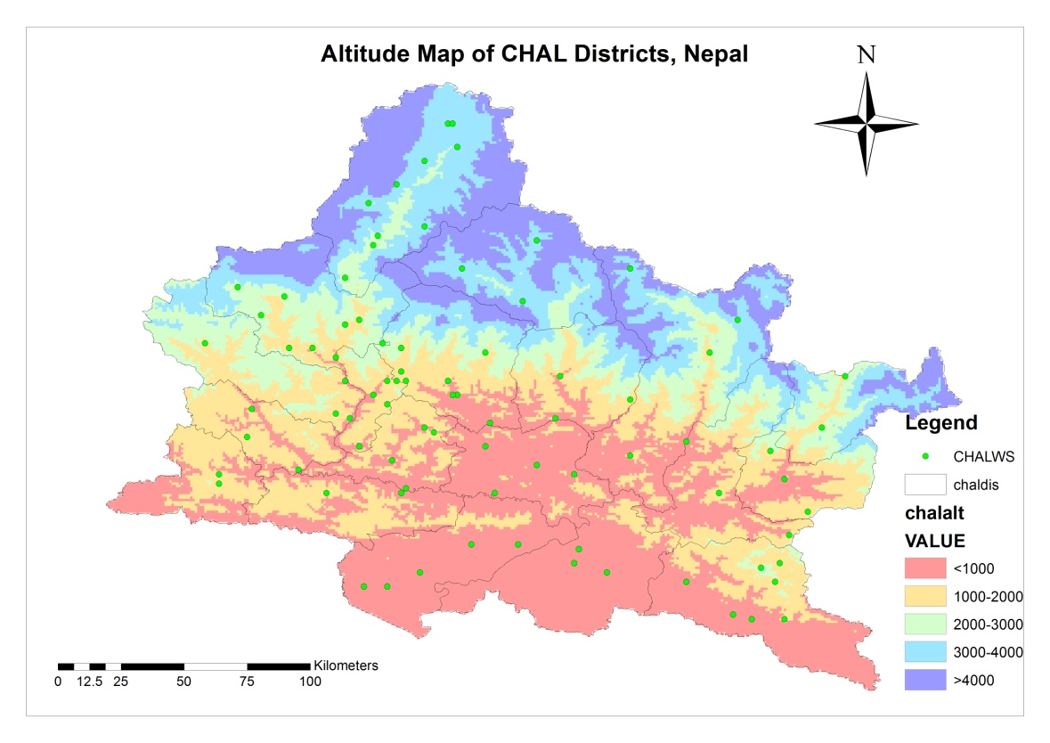

Fig.2. Altitude map of Chitwan Annapurna Landscape (CHAL) area, Nepal.

## Climate and Climate Change

Nepal has been listed as one of the most vulnerable countries to climate change. The climate in Nepal is governed by its topographic extremes (MOSTE, 2014). Nepal falls in the monsoon system of the Indian subcontinent and eighty percent of rain falls in monsoon season (PSN, 2009). The country receives over 5,000 mm of rain in Lumle (Kaski district) and around only 300 mm rain in trans-Himalayan region of Jomsom- Mustang falling in CHAL area. Eastern Nepal receives more rain than western Nepal. Rain generally increases with altitude up to 3000 m and above that, the precipitation decreases. The tropical zone of Nepal usually receives between 1,093 to 2,616 mm rainfall annually with an average of 1,709 mm/yr. A wide range of temperature is experienced in Nepal. Near zero to above 400C temperature is experienced in the tropical zone in winter to summer (PSN, 2009), whereas in the Nival zone above 5,000 m, it falls down to -200 C.

The regular and complete sets of temperature data are available from 34 weather stations in the Chitwan Annapurna Landscape area. Among them, 19 weather stations occur below 1,200 m altitude, 14 weather stations at the elevation range of 1,200 to 3,600m and one station at 3,800m altitude. Analysis of the last few years reveals that the average annual rainfall in CHAL area decreased according to altitude. The temperature increase in CHAL area was recorded nearly 0.01 to 0.060C per year at different altitudes. It was the lowest at <200 m and the highest increase at >3,800 m altitude.

## Invasive Species

Some major and dominant invasive species recorded in Nepal listed in IUCN (2005) that will be included in this study.

### *Ageratum adenophora* (Asteraceae)

**Common name:** Crofton weed.

**Local name:**  Kalo banmara, Kaloharam, Raunne, Hawe, Assame/ Barmeli, Kalo teta, Kalimunte, Mohini (Chepang), Thanga Pa Mraan (Tamang)

**Habitat:** Open forest margins, grasslands, agricultural lands and fallow lands

**Description:** It is a native of Mexico, but has naturalized in many countries. It was introduced into several parts of the world as an ornamental in the nineteenth century and is now an established invasive weed in many subtropical regions of Asia. It grows into an erect herb (occasionally into a shrub) of one to three meters in height, with trailing purplish to chocolate-brown branches that strike roots upon contact with soil, resulting in dense thickets. The base of the plant is woody and densely clothed with stalked glandular hairs. Dispersal occurs by wind-borne seeds and each plant produces about 100,000 seeds per season. Seeds are also spread by water, as contaminants of agricultural produce, via gravel used in road construction, soil sticking to animals, machinery, vehicles, and by adhering to footwear or clothing of farm workers. Dense stands can contribute up to 60,000 viable seeds per square meter to the seed bank. It is considered as a serious weed in agriculture, especially in rangelands and forests. It is generally unpalatable to grazing animals but fatally toxic to horses. Because of its allelopathic properties, it reduces growth of nearby plants. It reduces biodiversity by suppressing native vegetation, interferes with the movement of wildlife, depletes soil nutrients and clogs irrigation channels (Muniappan et al., 2009).

**Distribution:** Nepal (WCE, 650-2400m)

### *Chromolaena odorata* (Asteraceae)

**Common name:** Siam weed, bitter bush, chromolaena.

**Local name**: Aule banmara, Seto banmara, Seto Raunne, Assame/ Barmeli, Teta, Aule jhar, Madhese banmara, Singhar (Chepang), Lohasiya (Danwar), Seto haram (Rai).

**Habitat:** Edges of forests, disturbed forests, fallow lands, agricultural lands and grasslands.

**Description:** It is a weedy pioneering shrub native to the Americas from southern USA to northern Argentina. From its original point of introduction as an ornamental plant in northeastern India in the mid nineteenth century, it has spread to Southeast Asia, parts of Oceania, west and eastern Africa. A different form of *C. odorata* occurs in South Africa. It is scrambling perennial shrub and it can grow up to 5-10 m when supported by other vegetation. Plants grow vigorously throughout the wet season and flowering in initiated by a decrease in both day length and rainfall. Flowering peaks in December-January and seeds are set in March in the northern hemisphere. Fertile seeds are produced without pollination, as the species is apomictic. During the dry season, the shoots dry up and become a fire hazard. The allelopathic properties of the weed aid it gaining dominance in vegetation, and in replacing other aggressive invaders such as *Lantana camara* and *Imperata cylindrica* (Zachariades et al., 2009).

**Distribution:** Nepal (WCE, 75-1540m)

### *Eichhornia crassipes* (Pontederiaceae)

**Common name:** Water hyacinth

**Local name**: Jal Kumbhi, Ghenga, Meteka, Dalkacchu (Tharu), Pindale Jhar, Jalu, Kane, Ghengana.

**Habitat:** Wetlands, marshes, lakes, ponds, ditches and rivers.

**Description:** It is an erect free-floating herbaceous plant, indigenous to tropical South America, but has spread throughout the world. It colonizes still or slow moving waters, resulting in thick extensive mats, which impede water traffic, reduce water quality and alter social structures for human riparian communities. Reproduction is both sexual and vegetative. Seeds are long-lived and can remain viable for up to 20 years. However, the main mode of population increase is vegetative. It is recognized as the world’s worst aquatic weed, because of the significant ecological impacts it has on the environment, and the associated cascading socioeconomic effects. Dense impenetrable mats restrict access to water, negatively impacting fisheries and related commercial activities, the effectiveness of irrigation canals, navigation and transport, hydroelectric programs, and tourism (Coetzee et al., 2009).

**Distribution:** Nepal (WCE, 75-1500 m)

### *Parthenium hysterophorus* (Asteraceae)

**Common name:** Bitter weed, Carrot grass, False ragweed, Fever few, Parthenium weed, Ragweed parthenium, White top, Santa Maria

**Local name:** Kanike ghans, Bethu ghans, Padke phul

**Habitat:** Fallow lands, roadsides, parks, Pastures, around settlements

**Description:** It is an annual herb with a deep-penetrating taproot system and an erect shoot system. Young plants form a rosette of leaves close to the soil surface. As it matures, the plant develops many branches on its upper half, and may eventually grow up to two meters. It is a prolific seed producer and a fully-grown plant can produce more than 15,000 seeds in its lifetime. Parthenium can grow in a wide range of landscapes, including degraded and disturbed lands, pastures, croplands, orchards, forests, and roadsides. It reduces richness and diversity of other plant species, serves as a reservoir for plant pathogens and insect pests of crops, causes dermatitis and allergies in humans, is generally unpalatable and toxic to cattle and sheep, and consumption will taint meat and milk (Dhileepan and Strathie, 2009; Shrestha et al., 2015).

**Distribution:** Nepal (WCE, 75-1350 m).

### *Lantana camara* (Verbenaceae)

**Common name:** Lantana

**Local name**: Ban phanda, Kirne kanda, Banmakai, Sutkeri kanda, Subandi, Kaligedi, Aankeri kanda, Kharbuja, Kanchi nani, Boksi kanda, Gandhe kanda, Chilaune jhar, Bhakte kanda, Masino kanda, Vanphanda kanda, Ek sanse

**Habitat:** Forests, fallow lands, pastures, roadsides.

Description: It is a weed of neotropical origin and pantropical distribution. It is a straggling erect or sub-erect shrub, grows up to 3 m high with stout recurved prickles. It can grow in individual clumps or thickets. Its allelopathic properties reduces biodiversity and displaces desirable species. It outcompetes native pastures and interferes with mustering of cattle and movement of wildlife in the forests. In addition, it reduces productivity of orchards and plantations and interferes with harvesting (Day and Zakucki, 2009).

**Distribution:** Nepal (WCE, 75-1700 m)

## METHODOLOGY

### Species selection:

The five invasive alien species (IAS) i.e. *Ageratina adenophora*, *Chromolaena odorata*, *Eichhornia crassipes*, *Lantana camaraand*, and *Parthenium hysterophorus* will be studied.

### Delineation of quadrates or areas of interest (AOI):

According to the species distribution in Nepal as reported by the previous studies a quadrate of 10 km2 will be constructed in five different elevation and physiographic zones as follows:

1. Up to 300 m at sub-tropical sparse hardwood forest/vegetation regime with intensive human domination of Terai plain.
2. 300 m to 600m at sub-tropical dense hardwood forest/vegetation regime with less human domination of Bhawar and Siwalik hills.
3. 600m to 1,000 m at sub-tropical mixed forest/vegetation regime with intensive human domination areas of Midland River Valleys.
4. 1,000 to 1,500m at sub-tropical and temperate mixed but sparse forest/vegetation regime with intensive human domination of Midland Hill-slopes.
5. 1,500 to 2,500m temperate mixed forest/vegetation regime with less human domination regime of high Himalayan south facing slopes and river valleys.

### Field study and research modality:

This study has been designed for the capacity building of university students for their research under the direct supervision and guidance of the professors. Therefore, each quadrate will be assigned to each Master’s Degree student of the Central Department of Botany of Tribhuvan University for their Master’s Degree thesis research. Selection of students will be based on their interest and performance in the field of Remote Sensing (RS) and Geographic Information System (GIS) in their regular class work. The selected students will be intensively oriented towards the IAS phenology, RS and GIS operating systems and field survey.

### Data for the invasive species mapping

The appearance and increasing trend of distribution of invasive species or alien species are one of the major indicators of the climate change. Empirical evidences of the various parts of the world have proved that the invasive species are directly associated with the changing environmental conditions of the earth surface. Huang and Asner (2009) noted that invasions by alien species are among the most formidable of threats to ecosystems and human well-being. Biological invasions have been identified as a major non-climatic driver of global change.

A remote sensor is a key device that captures data about an object or scene remotely. Since objects (including vegetation) have their unique spectral features (reflectance or emission regions), they can be identified from remote sensing imagery according to their unique spectral characteristics. Over the past half century, remote sensing imagery has been acquired by a range of airborne and space-borne sensors from multispectral sensors to hyperspectral sensors with wavelengths ranging from visible to microwave, with spatial resolutions ranging from sub-meter to kilometers and with temporal frequencies ranging from 30 minutes to weeks or months.

Huang and Asner (2009) have widely discussed the application of remote sensing in the detection of alien species. Invaded vegetation may remain dominated by a single species for a long period of time. They have suggested that alien plant invasions can be studied using remote sensing when the invader presents a novel structure, phenology or biochemistry relative to neighboring native vegetation. A specific set of remotely sensed data and techniques can be utilized to study each type of invasion characteristic. They have suggested different platforms and satellite imaging sensors for different purposes and levels of understanding and mapping for invasive species (Table 1).

### Table 1. Summary of remote sensing applications for non-native plant studies.

|  |  |  |  |
| --- | --- | --- | --- |
| **Study Scale** | **Sensor specifications and examples** | **Species traits and remote sensing strategies** | **Limitations** |
| Moderate spatial/ spectral | -Spatial: 10-100 m.  -Temporal: Long (16-26 days).  -Spectral: < 20 bands.  -ASTER, SPOT, TM/ETM+. | Large stands.  -Different phenology to co-existing plants.  -Selection of images acquired in the right season. | -Coarse spatial and spectral resolutions unable to extract non-native species from a mixture of different plants. |
| High spatial | -Spatial: < 10 m.  -Temporal: Short (1-4 days).  -Spectral: ~5 bands.  -Aerial photographs, QuickBird, IKONOS | -Unique spatial patterns.  -Pronounced flowering season.  -Selection of images acquired in the right season. | -Inflexibility of airborne data collection.  -Pixel spacing still not fine enough to observe plants at the species level.  -Unable to detect plants with no distinct flowering pattern due to the coarse spectral resolution.  -Impractical for large scale monitoring due to the time intensive approach (e.g., visual inspection), and small spatial extents. |
| High temporal | -Spatial: ≥ 250 m.  -Temporal: Very short (1-2 days).  -Spectral: < 40 bands.  -AVHRR, MODIS. | -Unique phenological characteristics.  -Combination of models and time-series vegetation indices derived from the images. | -Insufficient spectral bands to extract non-native species from large pixels covering other plants, surfacesoils and senescent vegetation.  -Time-series vegetation pattern obscured by cloud and snow requiring a statistically sounded smoothing algorithm for noise removal.  -Difficult to conduct field validation due to the large plot size.  -Overwriting non-native species signals by climatic variations such as precipitation. |
| Hyperspectral | Spatial: Varied (0.5-30 m).  -Temporal: Varied.  -Spectral: > 100 bands.  -AVIRIS, Hyperion. | -Unique signatures in the hyperspectral space.  -Spectral mixture analysis.  -Biochemical analysis at the canopy level. | -No direct link between invasion mechanism and sophisticate hyperspectral analyses.  -A small swath width of data collected from aircraft restricting the ability for large spatial scale monitoring.  -Inflexibility of airborne data collection.  -High similarity in the spectral space among species. |
| Active remote sensing | Spatial: 0.5-100 m.  -Temporal: Varied.  -Spectral: 1 band.  -3-D view.  -LiDAR, RADARSAT. | Large and pure stand.  -Monitoring the progress of species invasion from data acquired at two time points. | No spectral information and data only useful with good field knowledge. |
| Image fusion | Spatial: ~0.5 m.  -Temporal: Varied.  -Spectral: 200+ bands.  -3-D view.  -Pushing the limits of spatial, spectral and dimensional resolutions in modern remote sensing.  -CAO. | Unique signatures in the hyperspectral space.  -Detection of non-native species of different height-levels (overstory and understory) at the very fine  spatial scale. | High cost of data collection.  -Requirement of high performance computing power.  -Inflexibility of airborne data collection.  Small spatial extents restricting very large spatial-scale monitoring. |

Source: After Huang and Asner (2009)

The distribution and its increasing trend of expansion of invasive species in the CHAL area is intended to be studied by using the different satellite imageries and field based inventory methods developed so far. Considering those developments following imageries with temporal, spectral and spatial resolution and algorithm of classification and identification will be applied (Table 2).

### Table 2: Temporal investigation, Satellite imageries and Methods

|  |  |  |  |  |
| --- | --- | --- | --- | --- |
| **Sensors/Imageries** | **Temporal region\*** | **Spectral region** | **Methods** | **Imageries sources** |
| ASTER (15 m resolution)  ETM+ (30 m resolution)  GeoEye/WorldView 2/3/4, (50 cm resolution)  Ikonos (80 cm resolution) | In between 2016 and 2018 | VNIR | NDVI/TNDVI  Knowledge-based Supervised classification  Maximum-likelihood classification,  Visual delineation | Purchase from the archive of respective company/sites either FTP or download.  (Depends upon the availability of expected cloud free and area coverage under study within the time frame). |
| ASTER  ETM+  GeoEye/WorldView 2/3 (70 cm resolution)  Ikonos (80 cm resolution) | In between 2010 and 2012 |
| ASTER and ETM+ | In between 2000 and 2005 | Download from the respective achieve and webpage |
| Landsat TM/ETM+ | In between 1990 and 1995 |  |

*Temporal region has been proposed to see the trend of species appearance and coverage in those periods of time and develop the modeling for the future. However, the annual range has been arranged to acquire the imageries with satisfactory level of sensors, cloud coverage and spectral and spatial resolutions.

### Imageries acquisition:

Imageries available in the archives of different specified years of study will be acquired by download from the archive as per the terms and condition of the respective copyright rules of the companies/organizations. Some of them may be free of cost requiring only acknowledgments and others may need payments. These will be identified as per the availability after a detailed search has been made.

### Imageries and classification:

After the acquisition of required satellite imageries from the archives, different algorithms of classification will be carried out based on the spectral and spatial resolution for respective imageries. The delineation will be made with the normalized differenced vegetation index (NDVI) and transformed normalized difference of vegetation index (TNDVI) as of the methodology developed based on several international experiences. The high resolution imageries will provide the details of species diversities. Both large spatial resolutions of the latest imageries will provide the better spatial accuracy of the species domination; however, classification as well as delineation processes will be determined by the practical capability. In the digital classification algorithm, the pixel segregation, supervised classification by using training sample, knowledge-based classification and fusion of several terrain information will be applied. Basic digital elevation model (DEM), water sources and human activities, specifically road network, vehicular mobility, market functions, and accessibilities to human settlements will be considered by using ancillary data. Finally, from these processes invasive species domination special units of different time periods will be mapped. The delineated area of a specific time period will be integrated with the help of geographic information system (GIS) for the further time series change detection and modeling.

### Accuracy assessment and triangulation:

Local knowledge about the IAS from the social survey conducted among the local knowledgeable people will be incorporated. A 100 x 100 m grid will be constructed and superimposed over the output of the satellite imageries. The accuracy of the species will be measured by the field survey as per the species domination in the invasive species with detecting their growth and domination. The species availability in the past 27 years’ growth will also be triangulated by asking the questions to the local knowledgeable people from the nearby settlements. Following the uniform process, the species mapping at five-year intervals starting from 1990 to 2018 will be carried out to identify the time series invasion of IAS throughout the region.

### **Machine learning**:

Computational methods that combine ideas in GIS and machine learning to assess bio-diversity and its change in Nepal will be developed. These methods will combine detailed GIS data with satellite imagery to infer how bio-diversity is affected to due to climate change and human settlements. We will identify the rate of spread of identified invasive species from 1990 to 2018 and correlate it with the climate change in the CHAL region.

## TIMELINE

Overall study period is proposed for 18 months, which is roughly matched with the approximate thesis research period of the final year students. The specific time estimation is listed in Table 3.

### Table 3: proposed activities and estimated time calendar

|  |  |
| --- | --- |
|  |  |
|  | Activities | 1 | 2 | 3 | 4 | 5 | 6 | 7 | 8 | 9 | 10 | 11 | 12 | 13 | 14 | 15 | 16 | 17 | 18 |
| 1 | Conceptualization and Student selection | **** | *** |  |  |  |  |  |  |  |  |  |  |  |  |  |  |  |  |
| 2 | Field survey and identification of sites |  |  | *** | *** | *** |  |  |  |  |  |  |  |  |  |  |  |  |  |
| 3 | Software familiarization training for imageries and data handling |  |  | *** | *** |  |  |  |  |  |  |  |  |  |  |  |  |  |  |
| 4 | Satellite Imageries download/purchase |  |  |  | ** | *** | *** | *** | *** | *** |  |  |  |  |  |  |  |  |  |
| 5 | Preparation for the Image classification schemes |  |  |  |  | *** | **** | *** | *** | *** |  |  |  |  |  |  |  |  |  |
| 6 | Image classification |  |  |  |  |  |  |  | ** | *** | *** | *** | *** | *** |  |  |  |  |  |
| 7 | Machine learning |  |  |  |  | *** | *** | *** | *** | *** | *** | *** | *** | *** | *** | *** | *** | *** |  |
| 8 | Field verification and accuracy assessment |  |  |  |  |  | *** | *** | *** | *** | *** | *** |  |  |  |  |  |  |  |
| 9 | Data interpretation |  |  |  |  |  |  |  | *** | *** | *** | *** | *** | *** | *** |  |  |  |  |
| 10 | Report writing |  |  |  |  |  | *** |  |  |  |  |  |  | *** |  |  |  |  |  |
| 11 | Student thesis defense |  |  |  |  |  |  |  |  |  |  |  | *** | *** | *** | *** | *** |  |  |
| 12 | Final reporting |  |  |  |  |  |  |  |  |  |  |  |  |  |  |  |  |  | *** |
| 14 | Seminar/paper writing/publishing |  |  |  |  |  |  |  |  |  |  |  |  |  |  | *** | *** | *** |  |

## REFERENCES

Brooks, T.M., Bakarr,M.I., Boucher,T., Da Fonseca,G.A.B., Hiltontaylor,C., Hoekstra,J.M., Moritz,T., Olivieri, S., Parrish,J., Pressey,R.L., Rodrigues,A.S.L., Sechrest,W., Stattersfield,A., Strahm,W., Stuart,S.N., 2004. Coverage provided by the global protected-area system: is it enough? BioScience 54: 1081-1091.

Coetzee, J.A., Hill, M.P., Julien, M.H., Center, T.D., Cordo, H.A., 2009. *Eichhornia crassipes* (Mart.) Solms-Laub. (Pontederiaceae). In: R. Muniappan, G.V.P. Reddy and A. Raman (eds.) Biological Control of Tropical Weeds using Arthropods. Cambridge University Press, 183-210 pp.

Day, M.D., Zalucki, M.P., 2009. *Lantana camara* Linn. (Verbenaceae). In: R. Muniappan, G.V.P. Reddy and A. Raman (eds.) Biological Control of Tropical Weeds using Arthropods. Cambridge University Press, 211-246 pp.

Dhileepan, K., Strathie, L. *Parhenium hysterophorus* L. (Asteraceae). In: R. Muniappan, G.V.P. Reddy and A. Raman (eds.) Biological Control of Tropical Weeds using Arthropods. Cambridge University Press, 274-318 pp.

Dobremez, J. F., 1976. Le Nepal ecologie et biogeography. Editions du Centre National de la Recherche, Scientifique, Paris, France.

Dukes, J. S., Mooney, H A., 2004. Disruption of ecosystem processes in western North America by invasive species.*Rev.Chil.Hist.Nat.*77: 411-437.

Huang, C., Asner,G.P., 2009. Applications of remote sensing to alien invasive plant studies,Sensors, 2009, *9*, 4869-4889; doi:10.3390/s90604869. www.mdpi.com/journal/sensors.

IPCC., 2007. Climate Change 2007. Synthesis Report. A report of the Intergovernmental Panel on Climate Change (IPCC), Geneva, Switzerland.

IUCN., 2000. IUCN Guidelines for the Prevention of Biodiversity loss due to Biological Invasion.Gland, Switzerland.

IUCN., 2013. Aliens: The invasive Species Bulletin, Issue No.33, ISPRA, Rome, Italy.

Leo, L., Paul, J. B., Carol, R. J., 2000. Estimation of canopy-average surface-specific leaf area using Landsat TM data. Photogrammetric Engineering and Remote Sensing, 66, 183-191, [http://csee.eenv.uregina.ca/pesticide/ PMM/GIS&RS.htm](http://csee.eenv.uregina.ca/pesticide/%20PMM/GIS&RS.htm)).

MOSTE.2014. Nepal Second National Communication to United Nations Framework Convention on Climate Change, Ministry of Science, Technology and Environment, Government of Nepal.

Muniappan, R., Raman, A., Reddy, G,.V.P., 2009. *Ageratina adenophora* (Sprengel) King and Robinson (Asteraceae). In: R. Muniappan, G.V.P. Reddy and A. Raman (eds.) Biological Control of Tropical Weeds using Arthropods. Cambridge University Press, 63-73 pp.

Rejmanek, M., 1999. Invasive plant species and invasible ecosystems. In: Invasive Species and Biodiversity Management. In: O. Sandlund, P. Schei and A. Viken (Eds.) Kluwer Academic Publishers, Dordrechr, The Netherlands, pp. 79-102.

Shrestha, B.B., Shabbir, A., Adkins, S.W., 2015. *Parthenium hysterophorus* in Nepal: a review of its weed status and possibilities for management. Weed Research 55: 132-144.

Tiwari, S., Adhikari, B., Siwakoti, M., Subedi, [K., 2005. An](http://K.2005.An) Inventory and assessment of Invasive Alien Plant Species of Nepal. IUCN, Kathmandu, Nepal.115 pp.

Walther, G. R., Roques, A., Hulme, P. E., Sykes, M. T., Pysek, P,, Kuhn, I., Zobel, M., Bacher, S., Dukak, Z. B., Bugmann, H., Cruz, R., Dauber, J., Hickles, T., Jaresccck, V., Kennins, M., Klatz, S., Minchin, D., Moore, M., Setele, J., 2009. Alien species in a warmer world: risks and opportunities. Trends in Ecology & Evolution. 24: 686-693.

Zachariades, C., Day, M., Muniappan, R., Reddy, G.V.P., 2009. *Chromolaena odorata* (L.) King and Robinson (Asteraceae). In: R. Muniappan, G.V.P. Reddy and A. Raman (eds.) Biological Control of Tropical Weeds using Arthropods. Cambridge University Press, 130-162 pp.